Running Instructions and Project Details

**Section A: Basic Details**

|  |  |
| --- | --- |
| Project | CIMB_SG |
| Application URL | <https://www.cimb.com.sg/en/personal/home.html> |
| Test Scenario | **Scenario 2:**  Given I’m on CIMB page  And I navigate to Tools page from menu  When I access to ~~Property~~ Education Loan Repayment Calculator(Standard Repayment) from menu [Property Loan option not found, hence selected Education Loan]  Only below 2 tools found in tools page. I have selected “Education Loan Calculator (Standard Repayment) for this automation.    And I have inputted all necessary values  Then I will be able to see the Effective Interest Rate, Total Interest Payable and Total Amount Payable  And I will be able to see the loan repayment table with total loan tenure that I’ve entered  And different interest rates for different year based on my input |
| Automation Framework & Document created by | Vishwanatha Thimmanna Hebbar |
| Programming Language | Java |
| Tool | Selenium |
| Framework | TestNG |
| Design Pattern | Hybrid Framework ( Page Object Model (POM) design+Data driven framework) |
| Other Features | * Supports thread safe parallel execution * Generates Extent report along with inbuilt TestNG report * Generates logs * Takes screenshot of failed test case and attach to Extent report * Extent Reports are generated under Reports folder (Screenshots stored in Reports/Screenshots) along with TestNG reports. * Failed test case will re-run automatically for one more time, if you wish not to re-run automatically then corresponding listener at “testng.xml” may be commented or removed * Test cases can be run on “Dockerized selenium grid” infrastructure. Refer to section D.   **Note 1:**  I have added sample test “test_verify_title” , and made it intentionally fail at assertion stage to check screenshot is captured for failed test and to ensure failed test automatically re-runs one more time. Also to check for parallel execution. |
| GitHub Repository URL | https://github.com/vthebbar/CIMB_SG.git |
| Test Reports Folders | TestNG Report : test-output-> index.html and emailable-report.html  Extent Report : Reports-> ExecutionReport_dd-MM-yyyy hh-mm-ss.html |
| Logs stored at | Logs/CIMBSGWeb.log |

**Section B : Pull code from GitHub repository**

Pre-requisite : GIT Bash software is installed in PC and GIT HUB account

Step1 :Create folder in your pc

Step 2: Open GIT Bash (Right click inside the folder and click on : Git Bash Here

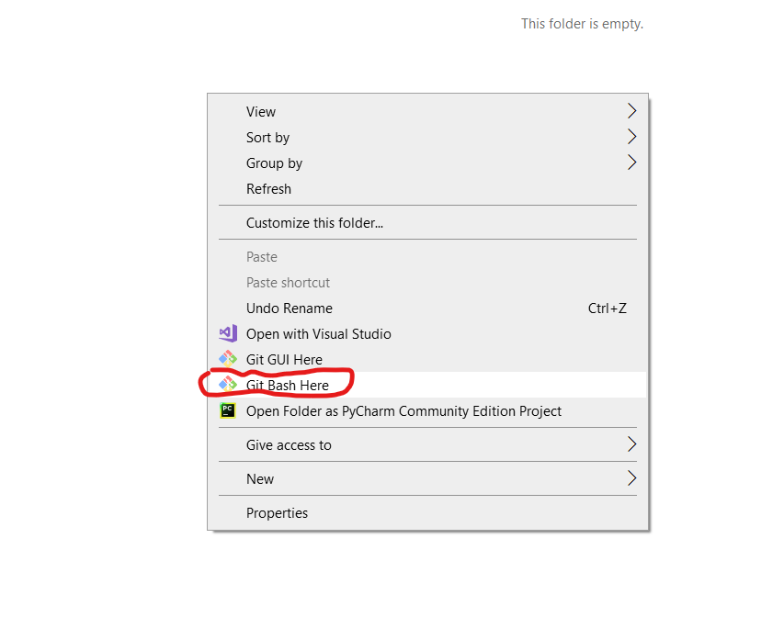

Step 3:

Run command > **git init**

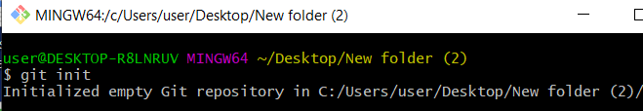

Step 4:

Run command > **git pull https://github.com/vthebbar/CIMB_SG.git**

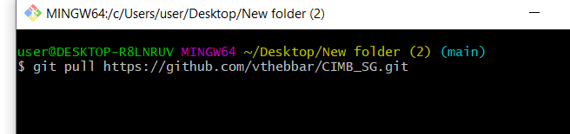

After step 4, project will be downloaded into the folder.

**Section C : How to Run the project on Standalone computer**

Approach 1A: Using “Run.bat” file in project home directory ( Preferred & easy Approach )

|  |
| --- |
| ->Double click on “Run.bat” file shown below and wait till execution completes.    ….………………………………………  Approach 1B:  Open windows command prompt and navigate to project home directory.  Run command> **mvn clean install** |

Approach 2: Run using “pom.xml” file

|  |
| --- |
| Step 1: Import the project in eclipse IDE    Step 2: Right click on: pom.xml -> select : Run as -> click on: Maven Test |

Approach 3: Run using “testng.xml” file

Step 1: Import project in eclipse IDE

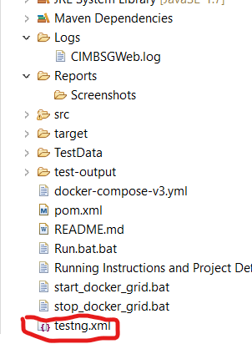

Step 2: Right click on : **testng.xml** file -> Select : Run as: -> Click on : TestNG Suite

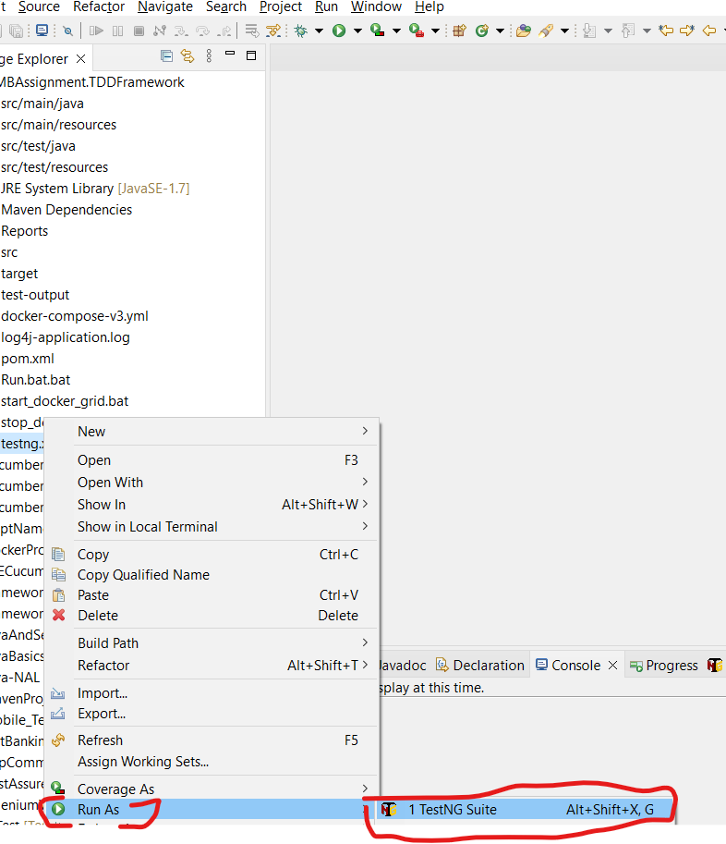

**Section D: How to run project on “Dockerized selenium grid” infrastructure using docker-compose**

If you wish to run tests on Dockerized selenium grid, then following steps to be followed.

Step 1: Download Docker Desktop [ <https://www.docker.com/products/docker-desktop/> ]

**Note2**: Docker Desktop must be on, automation code will automatically start grid infrastructure before test starts and shuts down once test completes.

You may also use any other existing docker infrastructure to run tests.

Step 2: Open “config.properties” file

Change -> run_on_grid=ON

grid_url -> Provide your grid URL

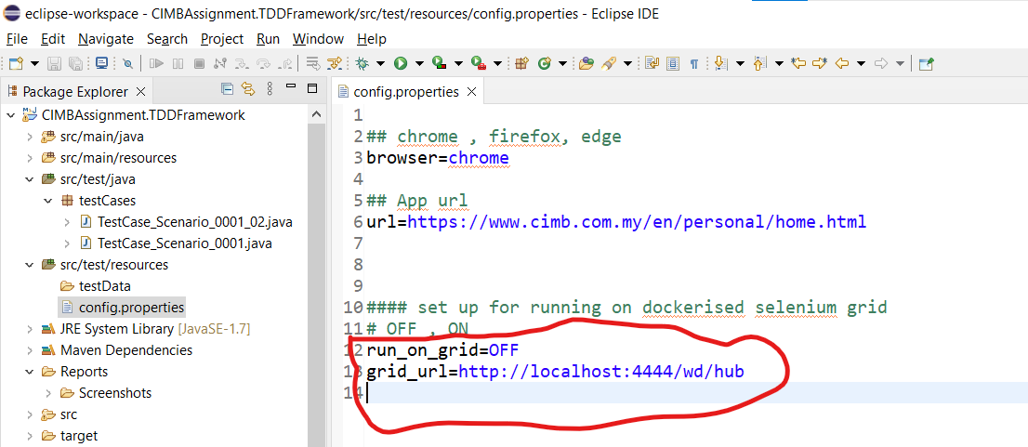

Step 3: Double click on “Run.bat” file

**Note 3:**

* For running on different browsers , update browser name in “config.properties” file

**Note 4:**

Report menu options:

